**📘 End-to-End Stock Price Prediction System (TCS & Other MNCs)**

**🔹 1. Data Pipeline (Backend ML Workflow)**

**Module 1: Financial Data Acquisition**

* Fetch stock data using **Yahoo Finance API**
* Save raw dataset → TCS_raw.csv

**Module 2: Data Cleaning & Feature Engineering**

1. **Handle Missing Values** → Forward-fill, Backward-fill
2. **Handle Outliers** → Boxplots, IQR clipping
3. **Feature Engineering**
   * SMA (10, 50)
   * EMA (20)
   * RSI (14-day)
4. Save dataset → TCS_cleaned_features.csv

**Module 3: Data Preparation**

* Convert date → ordinal
* Select features (Close, High, Low, Open, Volume, SMA, EMA, RSI)
* Normalize using **MinMaxScaler**
* Save scalers → scaler_X.pkl, scaler_Y.pkl

**Module 4: Models**

**🔹 ARIMA Model**

* Time-series model on Close price
* Forecast future values till 2027
* Save model → stock_model_arima.pkl

**🔹 LSTM Model**

* Neural network trained on 60-day closing price sequences
* Train-Test split → 80/20
* Trained for 20 epochs
* Save model → lstm_stock_model.keras
* 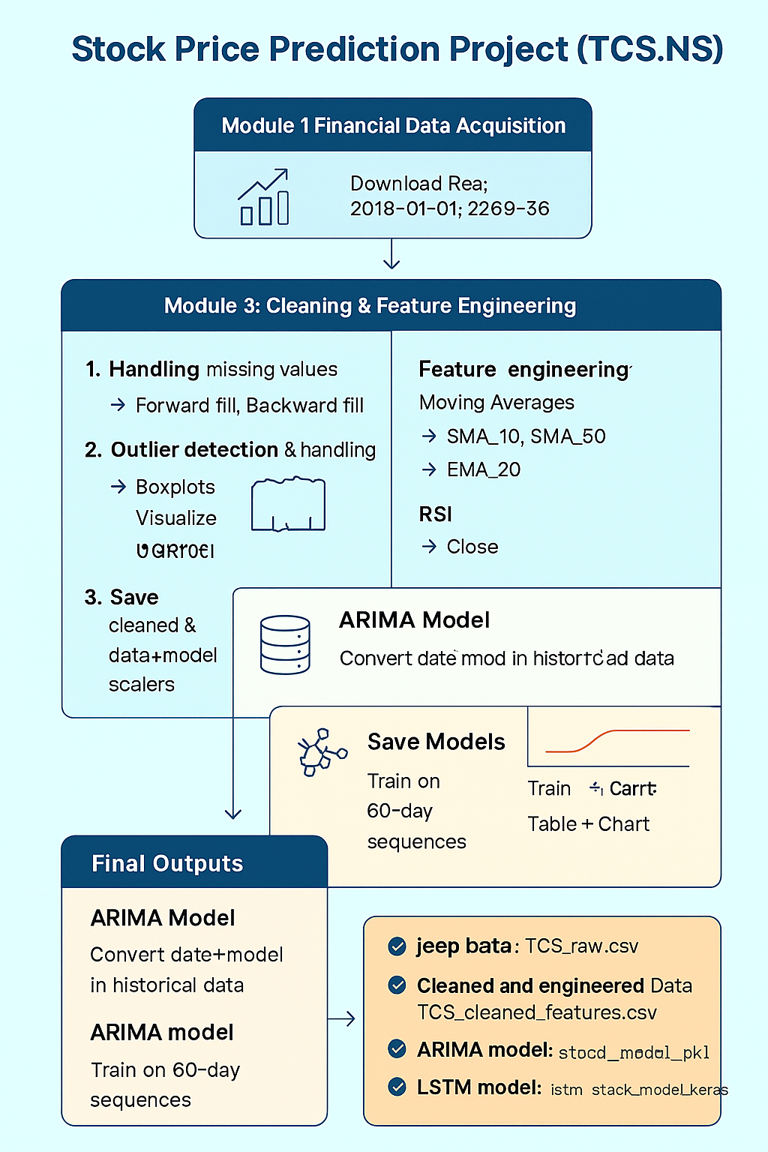

**🔹 2. Streamlit Application (Frontend for Users)**

**Step 1: User Authentication**

* 🔑 Login required
* Users:
  + saurabh / 12345
  + admin / admin123

**Step 2: Select Company**

* Dropdown list of top Indian MNCs (TCS, Infosys, Reliance, HDFC, SBI, etc.)
* Downloads last **5 years** of stock data from Yahoo Finance

**Step 3: Prediction Setup**

* User selects **future date**
* App calculates prediction steps = (future date – last available date)

**Step 4: Choose Mode**

1. **Single Model Mode**
   * Select **ARIMA** or **LSTM**
   * Output:
     + Predicted closing price on selected date
     + Last close price
     + 📈 / 📉 Trend + % change
     + Chart: Historical vs Forecast
2. **Comparison Mode**
   * Runs both **ARIMA & LSTM**
   * Outputs:
     + Table with predicted prices & % change
     + Highlights **best model** (closest to last close)
     + Chart: Historical + Both forecasts

**Step 5: Visualization Options (Sidebar)**

* **None** → Only predictions
* **Moving Averages** → SMA 10 & SMA 50 with closing price
* **Correlation Heatmap** → Feature correlation (Open, High, Low, Close, Volume)

**🔹 3. Final Outputs**

* 📁 Files generated:
  + TCS_raw.csv
  + TCS_cleaned_features.csv
  + stock_model_arima.pkl
  + lstm_stock_model.keras
  + scaler_X.pkl, scaler_Y.pkl
* 📊 App features:
  + Single or Comparison forecast
  + Interactive charts
  + Trend analysis
  + Moving averages & correlation heatmap

